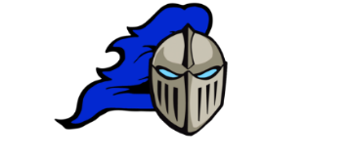
DLMS GYM SCHEDULE
DAY | MONDAY  February 9 |  | TUESDAY  February 10 |  | WEDNESDAY  February 11 | THURSDAY  February 12 | FRIDAY  February 13
School Day
Intramural  8:10-8:35 | Mighty Pucks  Vs  Zamboni Drivers |  | Rink Rats  Vs  Hat Trick Heroes |  | Zamboni Drivers  Vs  Ice Breakers | Hat Trick Heroes  Vs  Zamboni Drivers | No School
3:30-4:45 | DLMS2  Practice | DLMS3  Practice | DLMS1 Practice | DLMS2 Practice | MAA @ DLMS3  **4:00  Semi-Finals | DLMS1 Practice | DLMS1 Practice | DLMS2 Practice
HOME GAME | MAA @ DLMS1  5:00  Semi-Finals |  |  |  | GG @ DLMS1  5:00  (Semi-Finals) | NSER @ DLMS2  5:00
AWAY GAME |  |  |  |  |  | DLMS2 @ EWG  5:00  (Semi-Finals)

