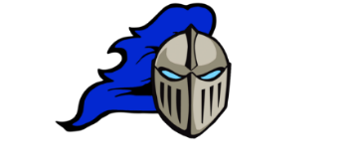
DLMS GYM SCHEDULE
DAY | MONDAY  November 17 | TUESDAY  November 18 |  | WEDNESDAY  November 19 | THURSDAY  November 20 | FRIDAY  November 21
School Day
Intramural  8:10-8:35 | Dunk Dynasty  Vs  Rim Reapers | Air Ballers  Vs  Brick Layers |  | Losier Legends  Vs  Dunk Dynasty | Air Ballers  Vs  Rim Reapers | No School
3:30-4:45 | DLMS3 Practice | DLMS1  Practice | DLMS2 Practice | DLMS1 Practice | DLMS2 Practice
HOME GAME |  | MAA @ DLMS2  5:00 |  | GG @ DLMS1  5:00 | NSER @ DLMS2  5:00
AWAY GAME | DLMS1 @ ECB  4:30 |  |  | DLMS3 @ Nelson  4 :30

